|  |  |  |
| --- | --- | --- |
| http://www.hcmus.edu.vn/images/stories/logo-khtn2009_transparency.png | **CS426- Mobile Device Application Development** |  |

Class: APCS 2017

Date: June 14-17, 2018 (72 hours)

**Mini Project 1**

**Personal Report**

**Student ID: 1751093**

**Student’s full name: NGUYỄN NGỌC PHONG**

**Email: nnphong@apcs.vn**

**Tel: 0914714360**

# Project Self Assessment

In this section, each student should personally evaluate his or her own effort to complete the project.

* For each feature, please determine the level of complexity (1-Very simple, 2-Simple, 3-Normal, 4-Difficult, 5-Very difficult) and level of completeness (100%).

|  |  |  |
| --- | --- | --- |
| **Feature** | **Complexity** | **Level of completeness**  **(100%)** |
| (A) | (B) | (C) |
| Recycle View for landscape mode | 3 | 100% |
| Bind data to recycle view | 3 | 100% |
| Fragment for landscape mode | 3 | 100% |
| Every book in recycle view is clickable and link to the more information of it | 4 | 100% |
| Being able to set and get value from firebase | 4 | 50% |
| UI for landscape mode | 3 | 100% |
| Add book based on user’s input | 4 | 100% |
|  |  |  |
|  |  |  |

# Advanced Features

Every book in recycle view is clickable and link to the more information of it

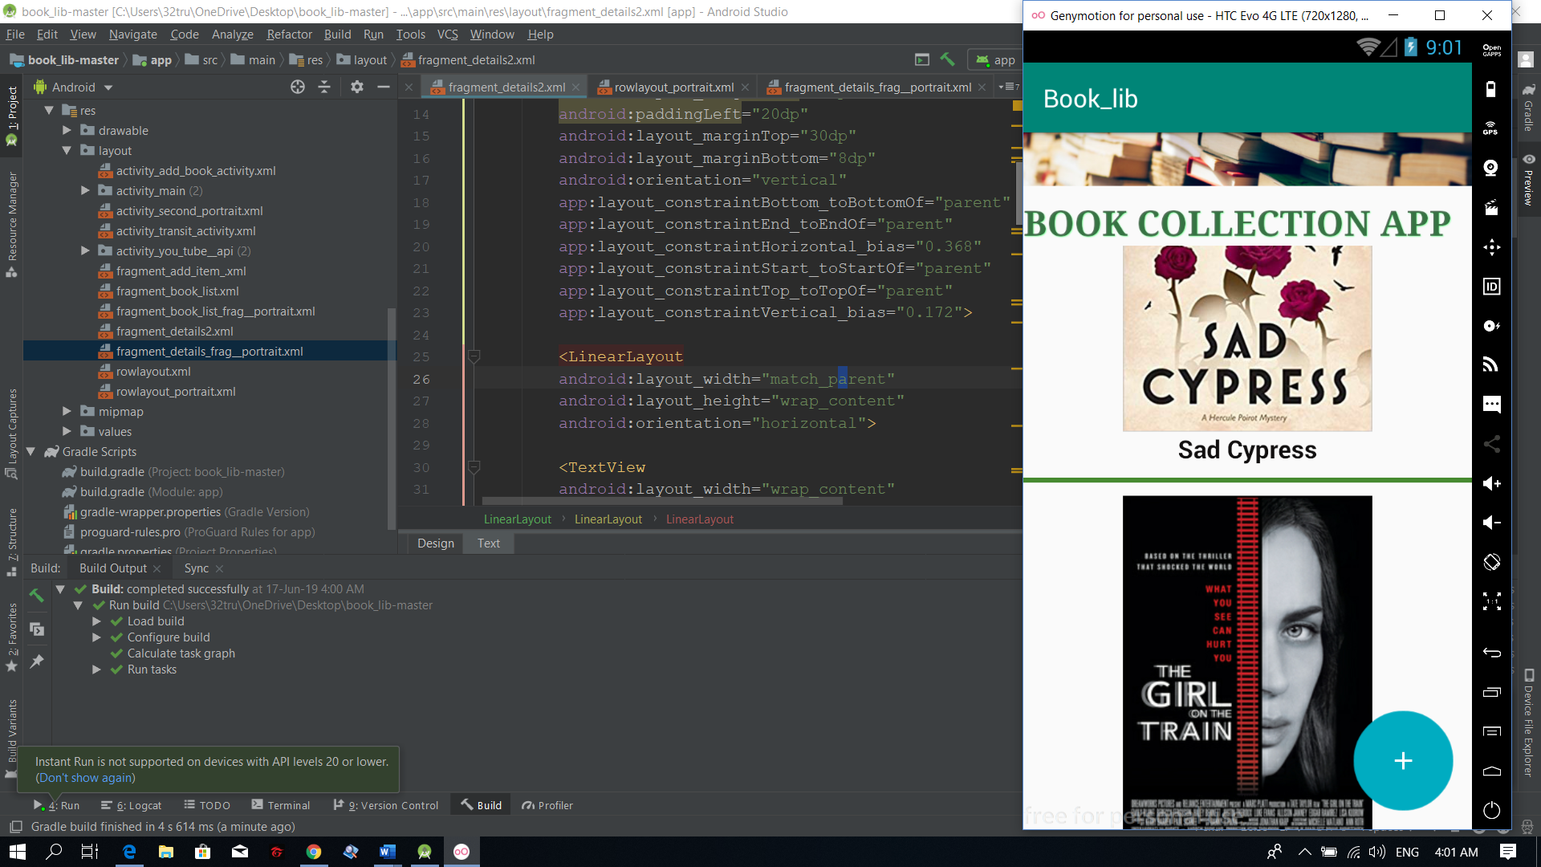

Being able to set and get value from firebase

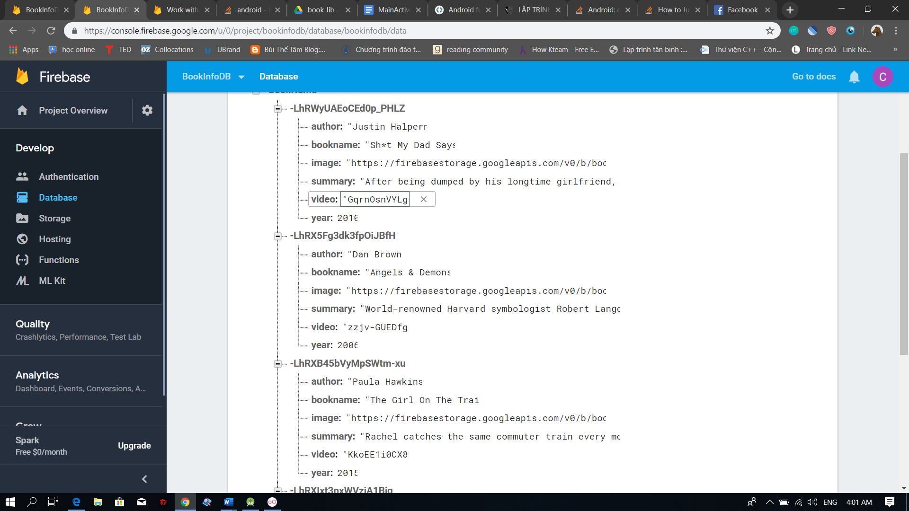

Add book based on user’s input

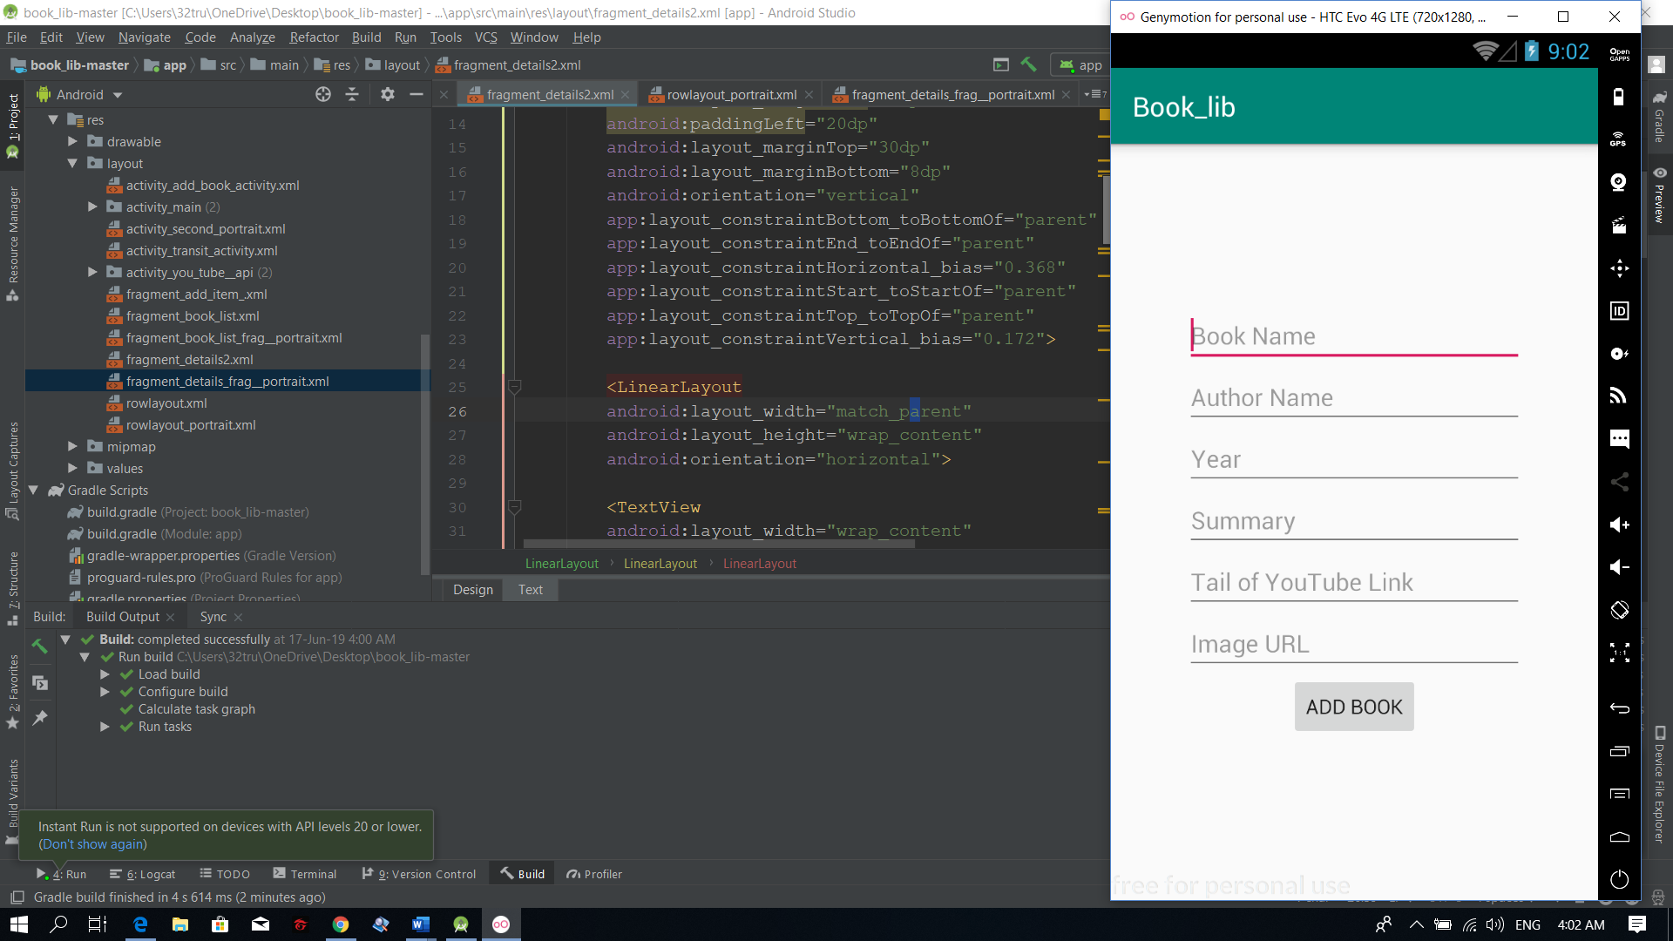

………

# Screenshots

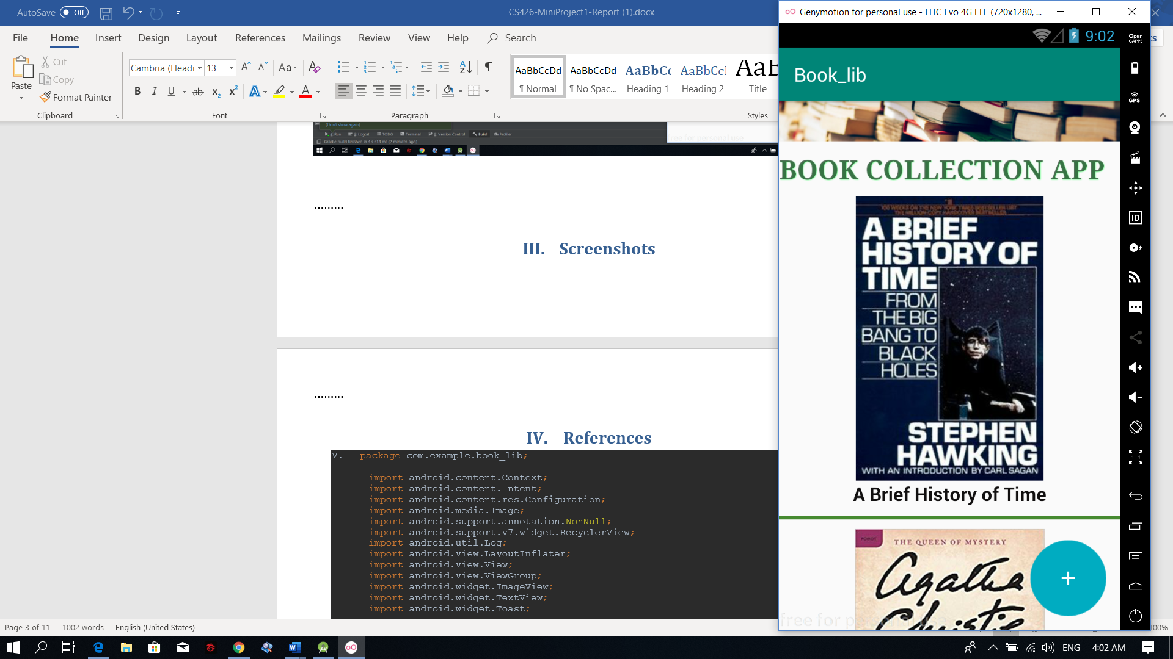

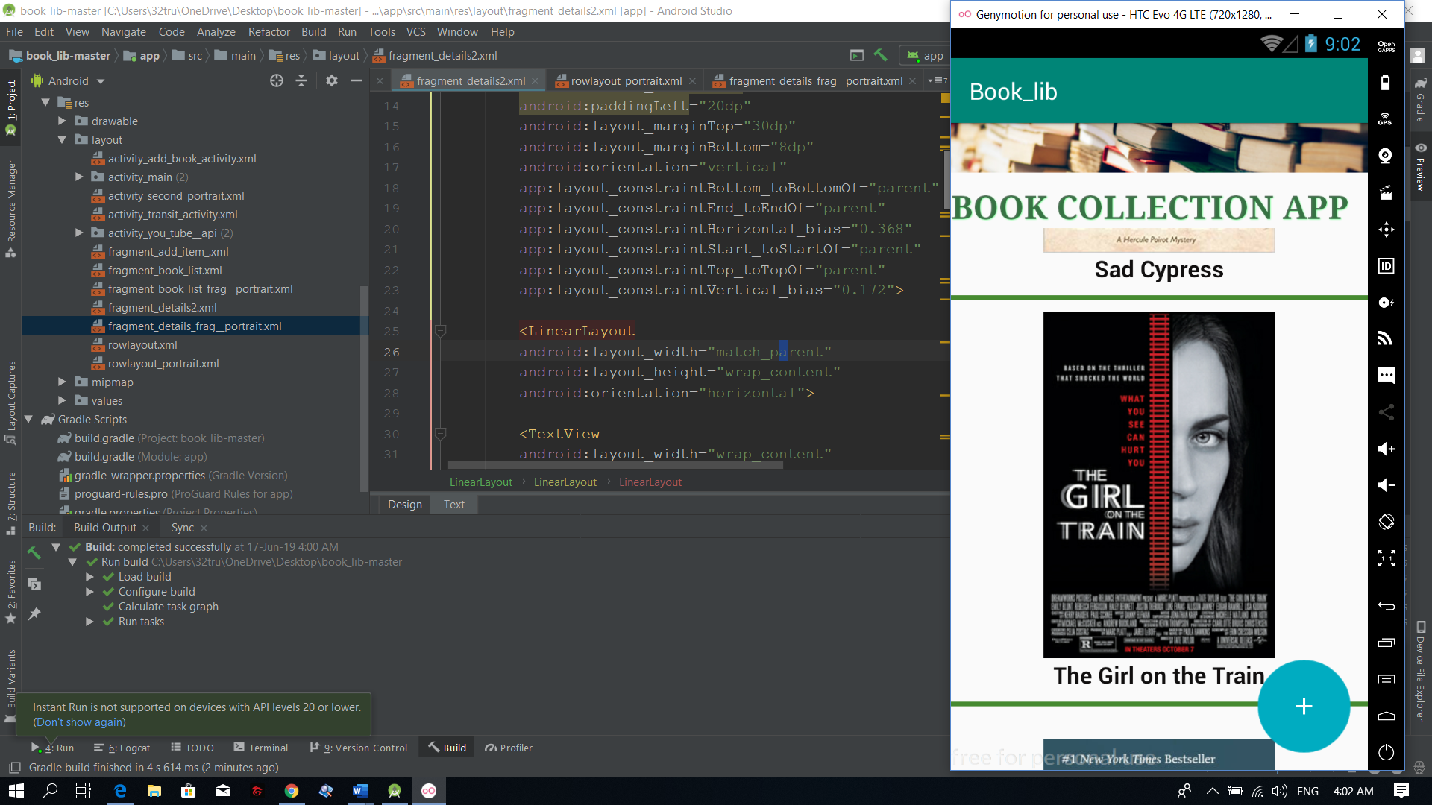

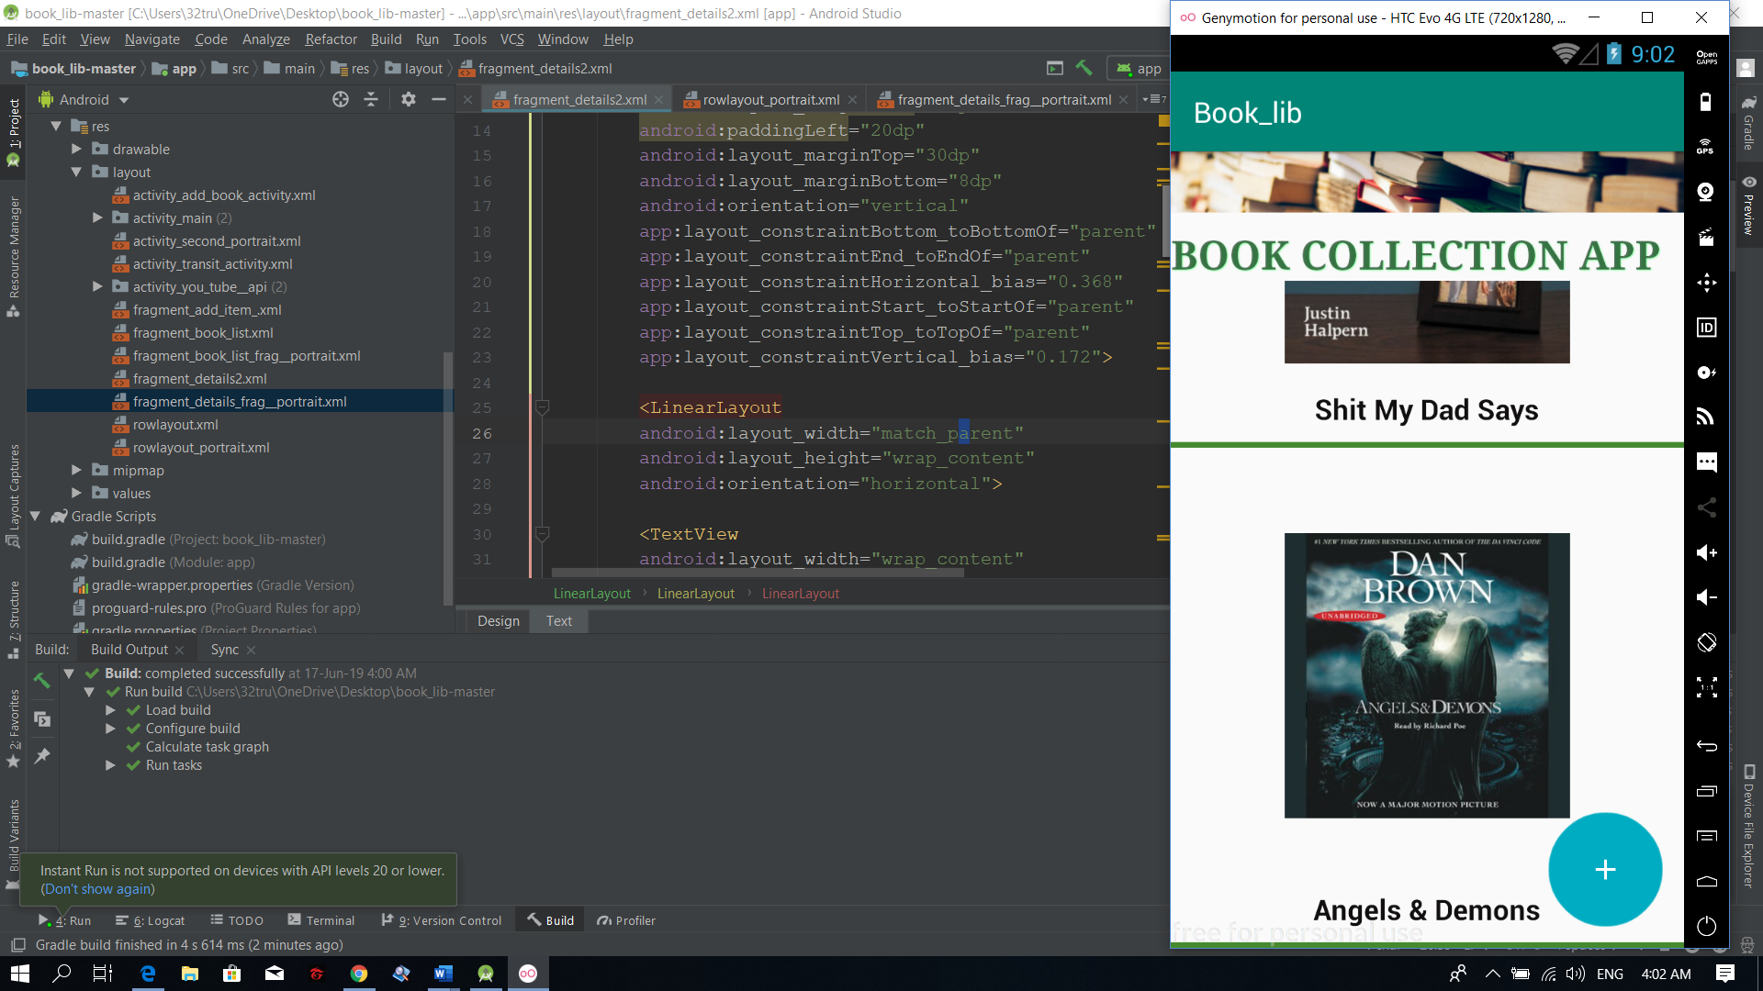

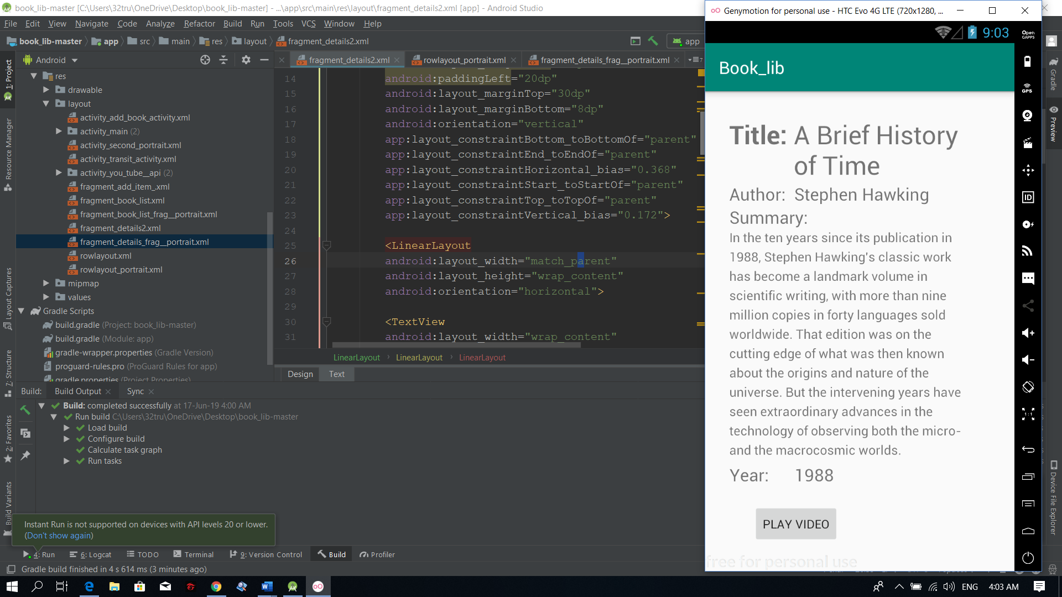

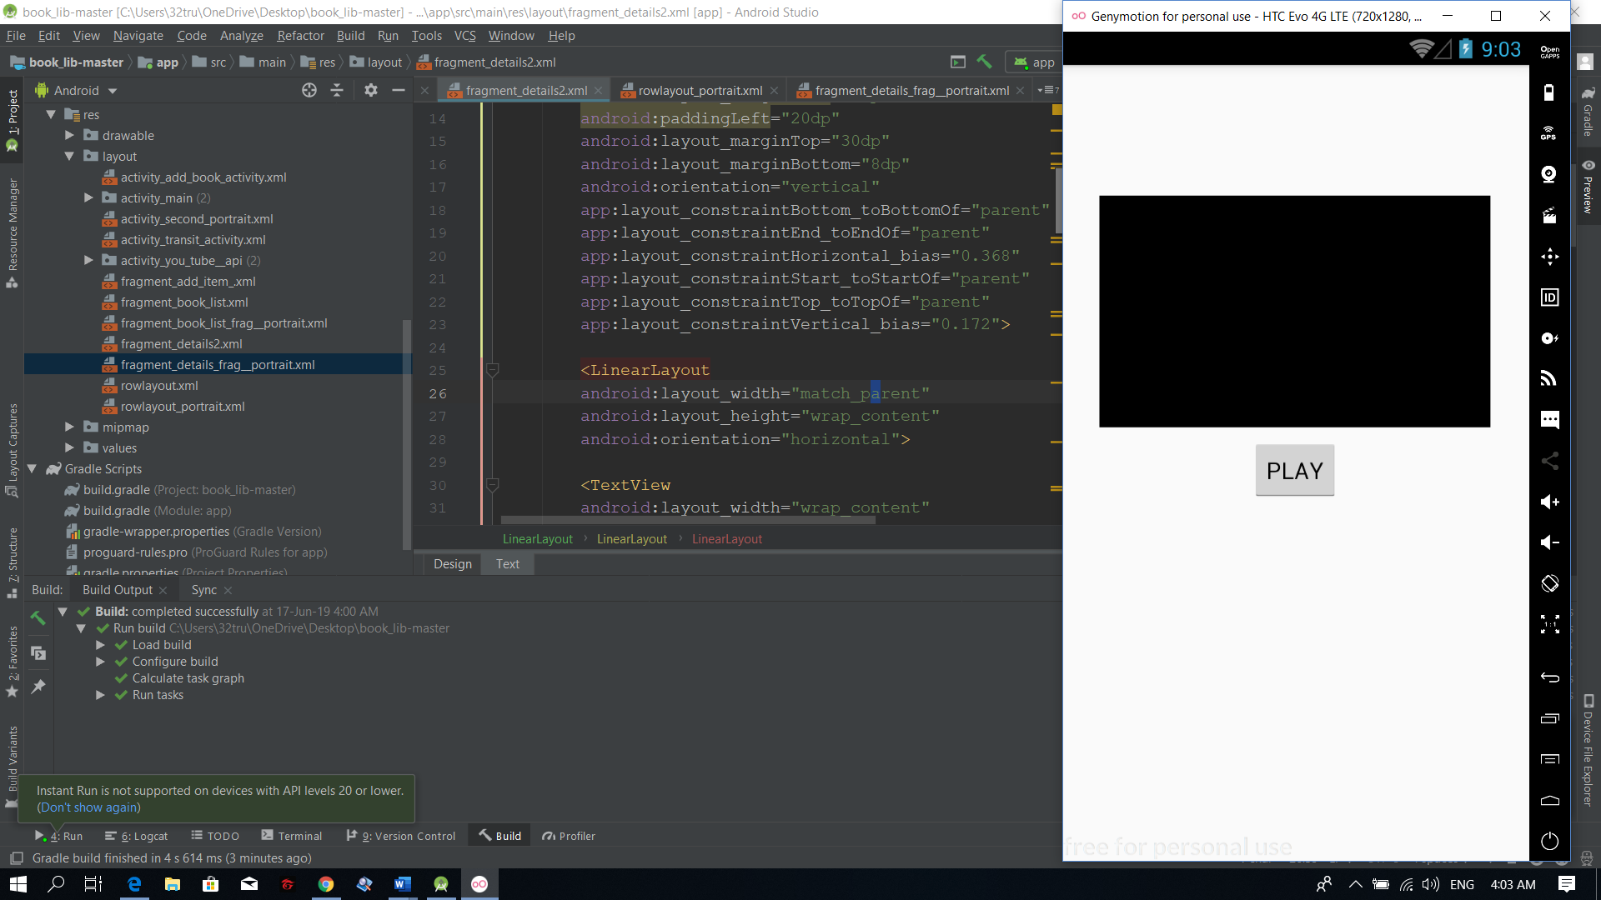

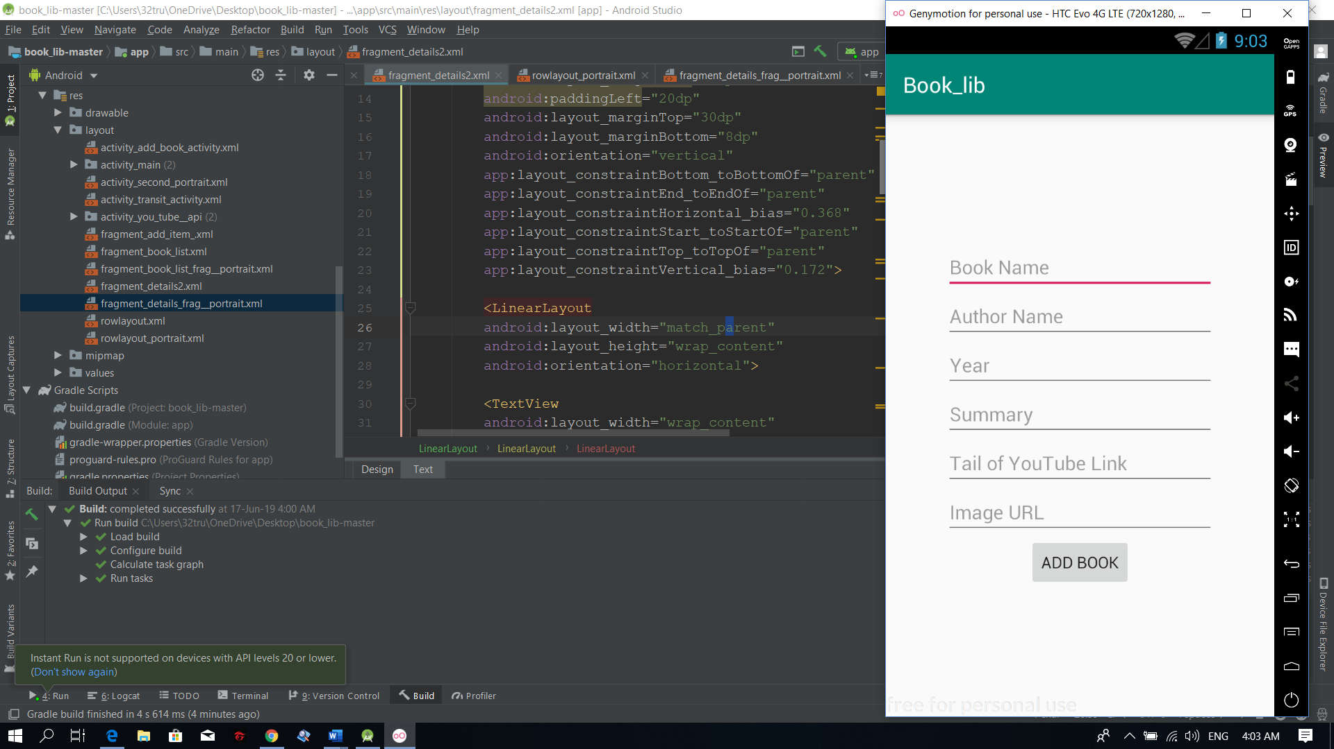

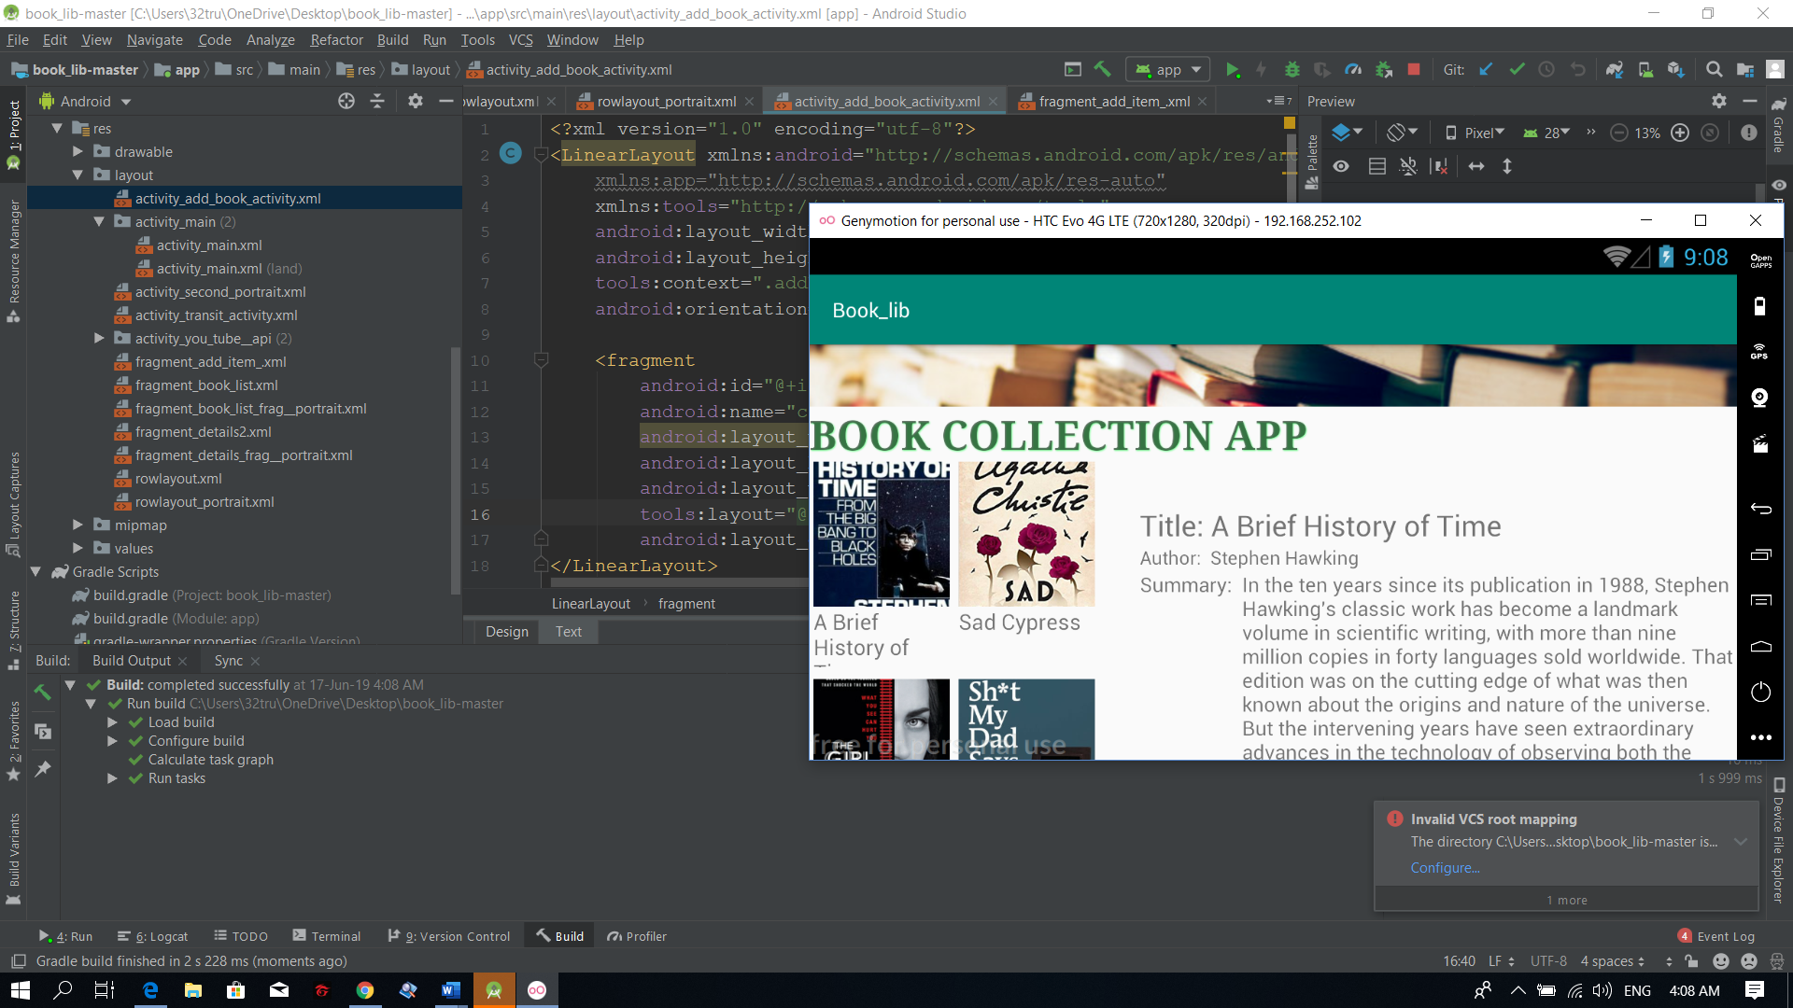

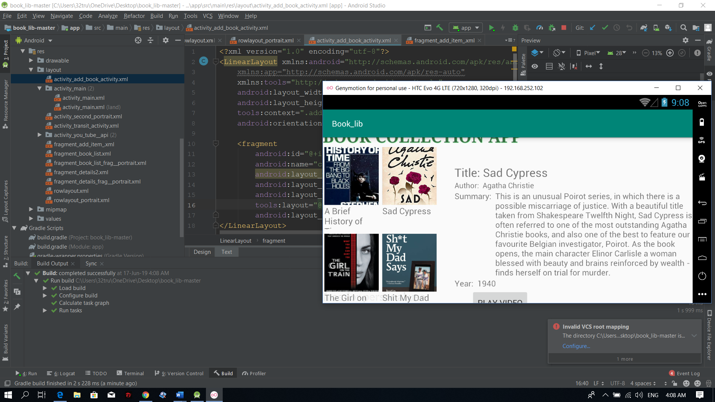

………

# References

1. package com.example.book_lib;  
     
   import android.content.Context;  
   import android.content.Intent;  
   import android.content.res.Configuration;  
   import android.media.Image;  
   import android.support.annotation.NonNull;  
   import android.support.v7.widget.RecyclerView;  
   import android.util.Log;  
   import android.view.LayoutInflater;  
   import android.view.View;  
   import android.view.ViewGroup;  
   import android.widget.ImageView;  
   import android.widget.TextView;  
   import android.widget.Toast;  
     
   import java.util.ArrayList;  
     
   public class BookAdapter extends RecyclerView.Adapter<BookAdapter.ViewHolder> {  
     
    private ArrayList<Book> books;  
    private RecyclerView mRecylerview;  
    private Context myContext;  
    public static final String *EXTRA_INDEX*="com.example.book_lib.EXTRA_INDEX";  
    private int landscape=2131230839;  
    ItemClicked activity;  
     
    public interface ItemClicked{  
    void onItemClicked(int index);  
    }  
     
     
    public BookAdapter(Context context, ArrayList<Book> list){  
     
    this.books=list;  
    this.myContext=context;  
    activity=(ItemClicked) context;  
     
    }  
    public class ViewHolder extends RecyclerView.ViewHolder{  
     
    TextView bookName;  
    ImageView bookImage;  
     
    public ViewHolder(@NonNull final View itemView) {  
    super(itemView);  
    if (mRecylerview.getId()==landscape)  
    {  
    System.*out*.println(itemView.findViewById(R.id.*bookNameLandscape*));  
    bookName=itemView.findViewById(R.id.*bookNameLandscape*);  
    bookImage=itemView.findViewById(R.id.*bookImgLandscape*);  
    }  
    else {  
    itemView.findViewById(R.id.*bookNamePortrait*);  
    bookName=itemView.findViewById(R.id.*bookNamePortrait*);  
    bookImage=itemView.findViewById(R.id.*bookImgPortrait*);  
    }  
     
    itemView.setOnClickListener(new View.OnClickListener() {  
    @Override  
    public void onClick(View v) {  
    System.*out*.println("New ID: "+mRecylerview.getId());  
    if (mRecylerview.getId()==landscape)  
    {  
     
    activity.onItemClicked(books.indexOf((Book) itemView.getTag()));  
     
    }  
    else {  
    int bookIndex=books.indexOf(itemView.getTag());  
    Intent intent=new Intent(myContext,Second_activity_portrait.class);  
    intent.putExtra(*EXTRA_INDEX*,bookIndex);  
    myContext.startActivity(intent);  
    System.*out*.println("books code: "+books.indexOf(itemView.getTag()));  
     
    }  
     
     
     
     
    }  
    });  
    }  
    }  
     
    @NonNull  
    @Override  
    public BookAdapter.ViewHolder onCreateViewHolder(@NonNull ViewGroup viewGroup, int i) {  
    View v;  
    if (mRecylerview.getId()==landscape) {  
    v = LayoutInflater.*from*(viewGroup.getContext()).inflate(R.layout.*rowlayout*, viewGroup, false);  
    }  
    else {  
    v = LayoutInflater.*from*(viewGroup.getContext()).inflate(R.layout.*rowlayout_portrait*, viewGroup, false);  
    }  
    return new ViewHolder(v);  
    }  
     
    @Override  
    public void onBindViewHolder(@NonNull BookAdapter.ViewHolder viewHolder, int i) {  
    viewHolder.itemView.setTag(books.get(i));  
    viewHolder.bookName.setText(books.get(i).getName());  
     
     
    }  
    @Override  
    public void onAttachedToRecyclerView(RecyclerView recyclerView) {  
    super.onAttachedToRecyclerView(recyclerView);  
     
    mRecylerview = recyclerView;  
    }  
     
    @Override  
    public int getItemCount() {  
    return books.size();  
    }  
   }

package com.example.book_lib;  
  
import android.content.Context;  
import android.net.Uri;  
import android.os.Bundle;  
import android.support.annotation.NonNull;  
import android.support.annotation.Nullable;  
import android.support.v4.app.Fragment;  
import android.support.v7.widget.GridLayoutManager;  
import android.support.v7.widget.LinearLayoutManager;  
import android.support.v7.widget.RecyclerView;  
import android.view.LayoutInflater;  
import android.view.View;  
import android.view.ViewGroup;  
  
  
///**  
// * A simple {@link Fragment} subclass.  
// * Activities that contain this fragment must implement the  
// * {@link BookListFrag.OnFragmentInteractionListener} interface  
// * to handle interaction events.  
// * Use the {@link BookListFrag#newInstance} factory method to  
// * create an instance of this fragment.  
// */  
public class BookListFrag extends Fragment {  
  
 RecyclerView recyclerView;  
 RecyclerView.Adapter myAdapter;  
 RecyclerView.LayoutManager layoutManager;  
 View view;  
 public BookListFrag() {  
 // Required empty public constructor  
 }  
  
  
  
 @Override  
 public View onCreateView(LayoutInflater inflater, ViewGroup container,  
 Bundle savedInstanceState) {  
 view=inflater.inflate(R.layout.*fragment_book_list*, container, false);  
 return view;  
 }  
  
 @Override  
 public void onViewCreated(@NonNull View view, @Nullable Bundle savedInstanceState) {  
 super.onViewCreated(view, savedInstanceState);  
  
 recyclerView=view.findViewById(R.id.*listBooks*);  
 recyclerView.setHasFixedSize(true);  
 layoutManager=new GridLayoutManager(this.getActivity(),2,LinearLayoutManager.*VERTICAL*,false);  
 recyclerView.setLayoutManager(layoutManager);  
  
 myAdapter=new BookAdapter(this.getActivity(),ApplicationClass.*bookArrayList*);  
 recyclerView.setAdapter(myAdapter);  
  
 }  
 public void notifyDataChanged(){  
 myAdapter.notifyDataSetChanged();  
 }  
}

package com.example.book_lib;  
  
  
import android.os.Bundle;  
import android.support.v4.app.Fragment;  
import android.view.LayoutInflater;  
import android.view.View;  
import android.view.ViewGroup;  
  
  
*/**  
 * A simple {****@link*** *Fragment} subclass.  
 */*public class DetailsFrag extends Fragment {  
  
  
 public DetailsFrag() {  
 // Required empty public constructor  
 }  
  
  
 @Override  
 public View onCreateView(LayoutInflater inflater, ViewGroup container,  
 Bundle savedInstanceState) {  
 // Inflate the layout for this fragment  
 return inflater.inflate(R.layout.*fragment_details2*, container, false);  
 }  
  
}

package com.example.book_lib;  
  
import android.content.Intent;  
import android.content.pm.ActivityInfo;  
import android.content.res.Configuration;  
import android.media.MediaPlayer;  
import android.net.Uri;  
import android.support.v4.app.Fragment;  
import android.support.v4.app.FragmentManager;  
import android.support.v7.app.AppCompatActivity;  
import android.os.Bundle;  
import android.view.View;  
import android.widget.Button;  
import android.widget.ImageButton;  
import android.widget.MediaController;  
import android.widget.TextView;  
import android.widget.VideoView;  
  
import com.google.android.youtube.player.YouTubeInitializationResult;  
import com.google.android.youtube.player.YouTubePlayer;  
import com.google.android.youtube.player.YouTubePlayerView;  
import com.google.firebase.FirebaseApp;  
  
public class MainActivity extends AppCompatActivity implements BookAdapter.ItemClicked {  
 TextView nameFrag,authorFrag,summaryFrag;  
 TextView yearFrag;  
 ImageButton addBtn;  
 Button reviewBtn;  
 String reivewURL;  
 static BookListFrag *bookListFrag*;  
 static BookListFrag_Portrait *bookListFrag_portrait*;  
 FragmentManager fragmentManager;  
  
  
 public static final String *EXTRA_SCREENMODE*="com.example.book_lib.EXTRA_SCREENMODE";  
 public static final String *EXTRA_URL*="com.example.book_lib.EXTRA_URL";  
 private int modeScreenNo;  
 @Override  
 protected void onCreate(Bundle savedInstanceState) {  
 super.onCreate(savedInstanceState);  
 setContentView(R.layout.*activity_main*);  
  
 fragmentManager= this.getSupportFragmentManager();  
  
 if (findViewById(R.id.*landscape_layout*)!=null) {  
  
 nameFrag = findViewById(R.id.*nameBookFrag*);  
 authorFrag = findViewById(R.id.*authorFrag*);  
 summaryFrag = findViewById(R.id.*summaryFrag*);  
 yearFrag=findViewById(R.id.*yearFrag*);  
 onItemClicked(0);  
  
 }  
 if (findViewById(R.id.*landscape_layout*)!=null)  
 {  
 System.*out*.println("Landscape mode");  
 *bookListFrag*= (BookListFrag) fragmentManager.findFragmentById(R.id.*listLandscape*);  
 System.*out*.println("BOOK LIST FRAG: "+ *bookListFrag*);  
 *bookListFrag_portrait*= null;  
 System.*out*.println("BOOK LIST FRAG PORTRAIT: "+ *bookListFrag_portrait*);  
 */***************************************/* addBtn=findViewById(R.id.*addBtnLandscape*);  
 modeScreenNo=1;  
 addBtn.setOnClickListener(new View.OnClickListener() {  
 @Override  
 public void onClick(View v) {  
 openAddItemIntent(modeScreenNo);  
 }  
 });  
 */***************************************/* reviewBtn=findViewById(R.id.*reviewBtnLandscape*);  
 reviewBtn.setOnClickListener(new View.OnClickListener() {  
 @Override  
 public void onClick(View v) {  
 openYoutubeReviewActivity();  
 }  
 });  
  
  
 }  
 else {  
 System.*out*.println("Portrait mode");  
 *bookListFrag*= null;  
 System.*out*.println("BOOK LIST FRAG: "+ *bookListFrag*);  
 *bookListFrag_portrait*= (BookListFrag_Portrait) fragmentManager.findFragmentById(R.id.*listPortrait*);  
 System.*out*.println("BOOK LIST FRAG PORTRAIT: "+ *bookListFrag_portrait*);  
 */********************************************/* addBtn=findViewById(R.id.*addBtnPortrait*);  
 modeScreenNo=0;  
 addBtn.setOnClickListener(new View.OnClickListener() {  
 @Override  
 public void onClick(View v) {  
 openAddItemIntent(modeScreenNo);  
 }  
 });  
 */******************************************/* }  
  
 }  
  
 private void openYoutubeReviewActivity() {  
 Intent intent= new Intent(this,YouTube_API.class);  
 intent.putExtra(*EXTRA_URL*,reivewURL);  
 startActivity(intent);  
 }  
  
 private void openAddItemIntent(int i) {  
 Intent intent=new Intent(this,addBook_activity.class);  
 intent.putExtra(*EXTRA_SCREENMODE*,i);  
 startActivity(intent);  
 }  
  
  
 @Override  
 public void onItemClicked(int index) {  
 nameFrag.setText(ApplicationClass.*bookArrayList*.get(index).getName());  
 authorFrag.setText(ApplicationClass.*bookArrayList*.get(index).getAuthor());  
 summaryFrag.setText(ApplicationClass.*bookArrayList*.get(index).getSummary());  
 yearFrag.setText(ApplicationClass.*bookArrayList*.get(index).getYear());  
 reivewURL=ApplicationClass.*bookArrayList*.get(index).getVideoURL();  
  
 }  
}

<?xml version="1.0" encoding="utf-8"?>  
<LinearLayout xmlns:android="http://schemas.android.com/apk/res/android"  
 xmlns:app="http://schemas.android.com/apk/res-auto"  
 xmlns:tools="http://schemas.android.com/tools"  
 android:layout_width="match_parent"  
 android:layout_height="match_parent"  
 tools:context=".addBook_activity"  
 android:orientation="horizontal">  
  
 <fragment  
 android:id="@+id/addBookFrag"  
 android:name="com.example.book_lib.addItem_Frag"  
 android:layout_width="wrap_content"  
 android:layout_height="wrap_content"  
 android:layout_weight="1"  
 tools:layout="@layout/fragment_add_item_"  
 android:layout_gravity="center_vertical"/>  
</LinearLayout>

<?xml version="1.0" encoding="utf-8"?>  
<LinearLayout xmlns:android="http://schemas.android.com/apk/res/android"  
 xmlns:tools="http://schemas.android.com/tools"  
 android:layout_width="match_parent"  
 android:layout_height="match_parent"  
 tools:context=".BookListFrag"  
 android:orientation="vertical">  
  
 <!-- *TODO: Update blank fragment layout* -->  
  
  
 <android.support.v7.widget.RecyclerView  
 android:layout_width="match_parent"  
 android:layout_height="match_parent"  
 android:id="@+id/listBooks"/>  
</LinearLayout>

<?xml version="1.0" encoding="utf-8"?>  
<LinearLayout xmlns:android="http://schemas.android.com/apk/res/android"  
 xmlns:app="http://schemas.android.com/apk/res-auto"  
 xmlns:tools="http://schemas.android.com/tools"  
 android:id="@+id/relativeLayout"  
 android:layout_width="100dp"  
 android:layout_height="150dp"  
  
 android:orientation="vertical"  
 android:paddingLeft="6px"  
 android:paddingRight="6px">  
  
  
 <ImageView  
 android:id="@+id/bookImgLandscape"  
 android:layout_width="100dp"  
 android:layout_height="100dp"  
 android:src="@drawable/briefhistoryoftime"  
 android:scaleType="centerCrop"/>  
  
 <TextView  
 android:id="@+id/bookNameLandscape"  
 android:layout_width="match_parent"  
 android:layout_height="42dp"  
 android:layout_marginBottom="8dp"  
 android:textAlignment="center"  
 android:textSize="15dp" />  
  
</LinearLayout>

<?xml version="1.0" encoding="utf-8"?>  
<LinearLayout xmlns:android="http://schemas.android.com/apk/res/android"  
 xmlns:app="http://schemas.android.com/apk/res-auto"  
 xmlns:tools="http://schemas.android.com/tools"  
 android:id="@+id/relativeLayout2"  
 android:layout_width="match_parent"  
 android:layout_height="match_parent"  
 android:orientation="vertical">  
  
 <LinearLayout  
 android:layout_width="match_parent"  
 android:layout_height="wrap_content"  
 android:layout_marginLeft="8dp"  
 android:paddingLeft="20dp"  
 android:layout_marginTop="30dp"  
 android:layout_marginBottom="8dp"  
 android:orientation="vertical"  
 app:layout_constraintBottom_toBottomOf="parent"  
 app:layout_constraintEnd_toEndOf="parent"  
 app:layout_constraintHorizontal_bias="0.368"  
 app:layout_constraintStart_toStartOf="parent"  
 app:layout_constraintTop_toTopOf="parent"  
 app:layout_constraintVertical_bias="0.172">  
  
 <LinearLayout  
 android:layout_width="match_parent"  
 android:layout_height="wrap_content"  
 android:orientation="horizontal">  
  
 <TextView  
 android:layout_width="wrap_content"  
 android:layout_height="match_parent"  
 android:text="Title: "  
 android:textSize="20dp" />  
  
 <TextView  
 android:id="@+id/nameBookFrag"  
 android:layout_width="wrap_content"  
 android:layout_height="match_parent"  
 android:textSize="20dp"  
 app:layout_constraintEnd_toStartOf="parent"  
 app:layout_constraintStart_toStartOf="parent"  
 app:layout_constraintTop_toTopOf="parent" />  
 </LinearLayout>  
  
 <LinearLayout  
 android:layout_width="match_parent"  
 android:layout_height="wrap_content"  
 android:orientation="horizontal">  
 <TextView  
 android:layout_width="wrap_content"  
 android:layout_height="match_parent"  
 android:text="Author: "  
 android:textSize="13dp"/>  
 <TextView  
 android:id="@+id/authorFrag"  
 android:layout_width="wrap_content"  
 android:layout_height="match_parent"  
 android:textSize="13dp"  
 app:layout_constraintEnd_toStartOf="parent"  
 app:layout_constraintStart_toStartOf="parent"  
 app:layout_constraintTop_toBottomOf="@+id/nameBookFrag" />  
 </LinearLayout>  
  
  
 <LinearLayout  
 android:layout_width="match_parent"  
 android:layout_height="wrap_content">  
 <TextView  
 android:layout_width="wrap_content"  
 android:layout_height="match_parent"  
 android:text="Summary: "/>  
 <TextView  
 android:id="@+id/summaryFrag"  
 android:layout_width="match_parent"  
 android:layout_height="wrap_content" />  
  
  
 </LinearLayout>  
  
  
 <LinearLayout  
 android:layout_width="match_parent"  
 android:layout_height="wrap_content">  
 <TextView  
 android:layout_width="wrap_content"  
 android:layout_height="match_parent"  
 android:text="Year: "/>  
 <TextView  
 android:id="@+id/yearFrag"  
 android:layout_width="match_parent"  
 android:layout_height="wrap_content" />  
  
 </LinearLayout>  
  
 <Button  
 android:id="@+id/reviewBtnLandscape"  
 android:layout_width="wrap_content"  
 android:layout_height="wrap_content"  
 android:layout_marginLeft="28dp"  
 android:text="PLAY VIDEO" />  
  
 </LinearLayout>  
</LinearLayout>

References : Youtube, Firebase Documentation, Google Services Library, Android Developer Documentation and code

………